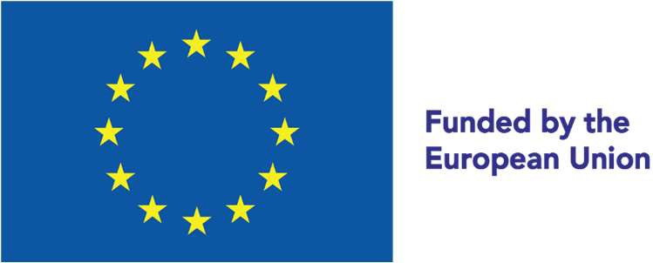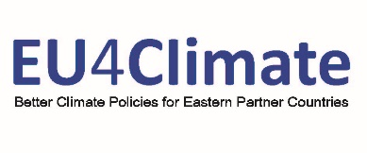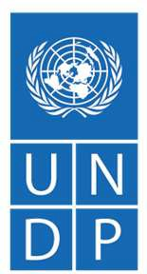

EU4Climate – Moldova

With a population of around 3.15 million (2019), Moldova contributes as little as 0.03% to the total global greenhouse gas (GHG) emissions and is amongst the lowest range of the per capita footprint with 4.4 t CO2e. The key emitter sectors are:

Energy  22.14% | Transport  18.9% | Agriculture  14.1% | Waste  11.2%
GHG emissions decreased between 1990 and 1995 by 60% and reached their lowest level in 2000 with 11,6 Mio t CO2eq. Since then, GHG emissions have slowly increased to more than 14 Mio. t CO2eq and stabilized since then. The substantial increase in GDP (+63% between 2010 and 2016) resulted in further decoupling of GHG emissions and economic development which is mainly driven by agricultural activities and the service sector. In its updated Nationally Determined Contribution (NDC), the Republic of Moldova has committed to more ambitious targets than in its first NDC.

The country’s new economy-wide unconditional target is to reduce its GHG emissions by 70% below its 1990 level in 2030, instead of 64-67% as committed in the first NDC, which could be further increased to 88%, if international low-cost financial resources, technology transfer, and technical cooperation are ensured. The BUR3 reports that over the last 132 years, the Republic of Moldova has experienced changes in average values of temperature and precipitation. The country had become warmer, with an average temperature increase of more than 1.2°C, while the increase in precipitation was only 51.3 mm.
Moldova is highly vulnerable to the effects of climate change and variability, and the socio-economic costs of climate change related hazards such as (1) droughts, (2) floods, (3) late spring frost, and (4) hail are significant.

1 | 2 | 3 | 4

Increasingly erratic weather patterns and extreme weather events have resulted in loss of life and income through rising food and energy prices.
The most vulnerable sectors are agriculture, human health, water resources, forestry, transport, and energy.

Climate change is streamlined into the main strategic planning document of the country - the National Development Strategy "European Moldova 2030" (2022). Moldova approved in 2017 its Low Emissions Development Strategy for the year 2030. The National Integrated Energy and Climate Plan of the Republic of Moldova will outline the climate change mitigation in the sector until 2030 and 2050 horizontal. The Republic of Moldova is advancing in the second cycle of its National Adaptation Planning process (NAP2) and the second iteration of the Climate Change Adaptation Strategy (until 2030) is developed and under promotion

Under the Climate Change Coordinating Mechanism, approved by the Government in 2020, the National Commission on Climate Change has been established as an inter-institutional body for the purpose of coordinating and promoting the measures and actions necessary for the unitary application on the territory of the Republic of Moldova of the provisions of the UNFCCC and of the Paris Agreement.

Climate policy development and advancing cooperation with the EU in Moldova
The EU-Moldova Association Agreement, including a Deep and Comprehensive Free Trade Area (AA/DCFTA), fully entered into force on 1 July 2016 after being applied provisionally since September 2014. The Agreement significantly strengthens the political association and economic integration between Moldova and the EU.
With extensive support from the EU, Moldova is making gradual progress on the approximation of the EU environmental and energy legislation to ensure energy security and diversify supply sources, including through renewable energy.

The EU has supported climate change related actions in the transport sector as well, amongst others, by improving clean public transport in the largest cities and restructuring and modernizing the Moldovan railway sector. Moldova is moving forward on its low-carbon and climate resilient development pathway, with strong support from the EU and international financing institutions.

2014 | - Association Agreement with the EU  - 3rd National Communication  - National Adaptation Strategy until 2020
2015 | - INDC 2016-2030  - COP21 Paris Agreement  - Pledge to Sustainable Development Agenda 2030
2016 | - Biennial Update Report 1 (BUR)  - LEDS (2016-2030)  - Revised National Renewable Energy Action Plan (NREAP) (2018 2020)
2017 | - LEDS 2030 entered into force  - Ratification of Paris Agreement  - Third GHG Inventory submitted
2018 | - Environment Agency set up  - 4th National Communication  - National Measurement, Reporting and Verification (MRV) System set up  - BUR2
2019 | - EU4Climate launched  - 3rd National Energy Efficiency Action Plan (NEEAP) (2019-2021)
2020 | - Draft F-gases Law  - Updated NDC (2021-2030)  - NAP 2 launched
2021 | - Draft updated LEDS 2030  - Enhanced Transparency Framework
2022 | - F-gases Law adopted  - National Development Strategy "European Moldova 2030" adopted  - MRV implementation capacity building
2023 | - Adoption of the updated LEDS 2030  - Adoption of the NAS  - Climate Chage law designed  - NECP designed

EU4Climate key policy interventions and expected impact
Low emission |  |  | Carbon resilient growth
Moldova is working towards establishing a strong foundation for low emission and climate resilient growth, being the fourth country to submit to UNFCCC a very ambitious second NDC. In addition, Moldovan Institutions increasingly recognize the importance of adapting to new climatic conditions and pledge a strong commitment to increasing preparedness to address disasters and climate risks.
However, being a developing country, with limited capacity, Moldova needs additional support to the national efforts through international financial, technological, and capacity building assistance.
On 23 June 2022, the European Council adopted conclusions on the membership applications from Ukraine, the Republic of Moldova and Georgia and has decided to grant the status of candidate country to Ukraine and to the Republic of Moldova, also recognizing the European perspective of Georgia.

EU4Climate in Moldova
The EU4Climate Programme, funded by the European Union, aims to support the development and implementation of climate-related policies by the Eastern Partnership countries.
The EU4Climate initiative supports Moldova in elaborating its long-term low emission development strategy and mainstreaming climate in the sectoral strategies. A robust domestic emissions monitoring, reporting and verification system will be established, to inform the government and the international community on the progress of its NDC implementation. Throughout the programme, the best international and EU practices will be applied.

Result areas and time frame in Moldova
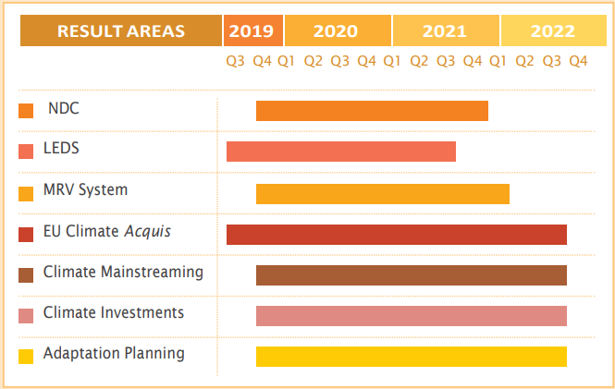

The EU4Climate substantial activities started in Moldova in the second half of 2019 and laid the footing for a systematic implementation of the requirements of the Paris Agreement and the commitments of Moldova under it. Throughout the programme, the best international and EU practices will be applied, including some alignment with the EU Acquis included in bilateral agreements and the Energy Community Treaty on Climate Action.

EU4Climate Moldova: Key results achieved in 2022

- Development of mid-century long-term LEDS
SEA procedure for the draft updated LEDS 2030 has been implemented.
- Introduction, when necessary, of robust domestic emissions MRV frameworks and strengthening of the existing ones
A 2-day national training on applying QA/QC for the MRV system was organized on 2-3 June 2022 for 42 participants, representatives of the institutions that are part of the National MRV system.
An interactive training course on GHG Inventory for energy sector was delivered on 31 October -1st November 2022 for more than 30 representatives of stakeholders of the Republic of Moldova
- Alignment with EU Acquis included in bilateral agreements and Energy Community Treaty on Climate Action
The f-gases Law was adopted in first lecture by the Parliament.
- Mainstreaming climate into other sectors, interinstitutional awareness (on policy and technical level)
Recommendations on climate change mainstreaming were formulated for the energy sector. A national workshop on mainstreaming climate aspects into energy sectoral policies was held on 24 February 2022 providing 40 government officials with recommendations for mitigating the climate change impacts on the energy sector. Additionally, Guideline on consolidation of climate and energy planning processes was developed with the view to ensure the coherence of the national climate and energy policy framework developed in the frame of Republic of Moldova’s commitments under UNFCCC and Energy Community Treaty.
- Communication and visibility actions
Awareness raising campaign in social media was conducted related to the UNFCCC COP 25 (UN Climate Change Conference).

Future Activities

- Development of the climate law
- Capacity building on the MRV implementation by training relevant stakeholders on GHG inventory in the waste sector
- Development of the NDC Financing Strategy
- Adoption of the Low Emission Development Strategy 2030.

The EU4Climate Programme helps governments in the six EU Eastern Partner countries to take action against climate change. It supports countries in implementing the Paris Agreement and improving climate policies and legislation.
EU4Climate assists the EaP countries to integrate the low-emissions and climate resilience objectives into development policies and plans, to improve and consolidate climate policies and legislative alignment. Its ambition is to limit climate change impact on citizens’ lives and make them more resilient to it.
The Programme builds on important achievements of past cooperation programmes, such as the EU’s ClimaEast Programme, which supported Climate Change Mitigation and Adaptation in Neighbourhood East and was completed in 2017. EU4Climate directly contributes to the targets of the Joint Staff Working Document “Recovery, resilience and reform: post 2020 Eastern Partnership priorities”, adopted in July 2021.
The scope of the Programme was defined in cooperation with all partner countries. The Initiative is implemented by the United Nations Development Programme. The European Commission provides the overall policy direction.
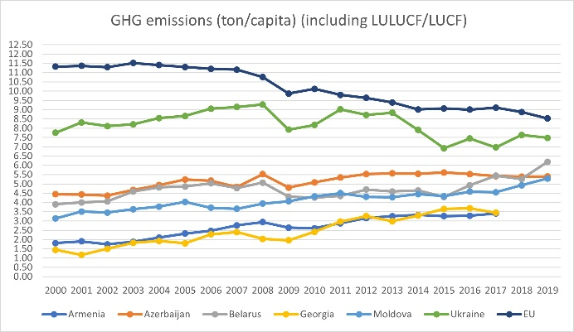 |  | 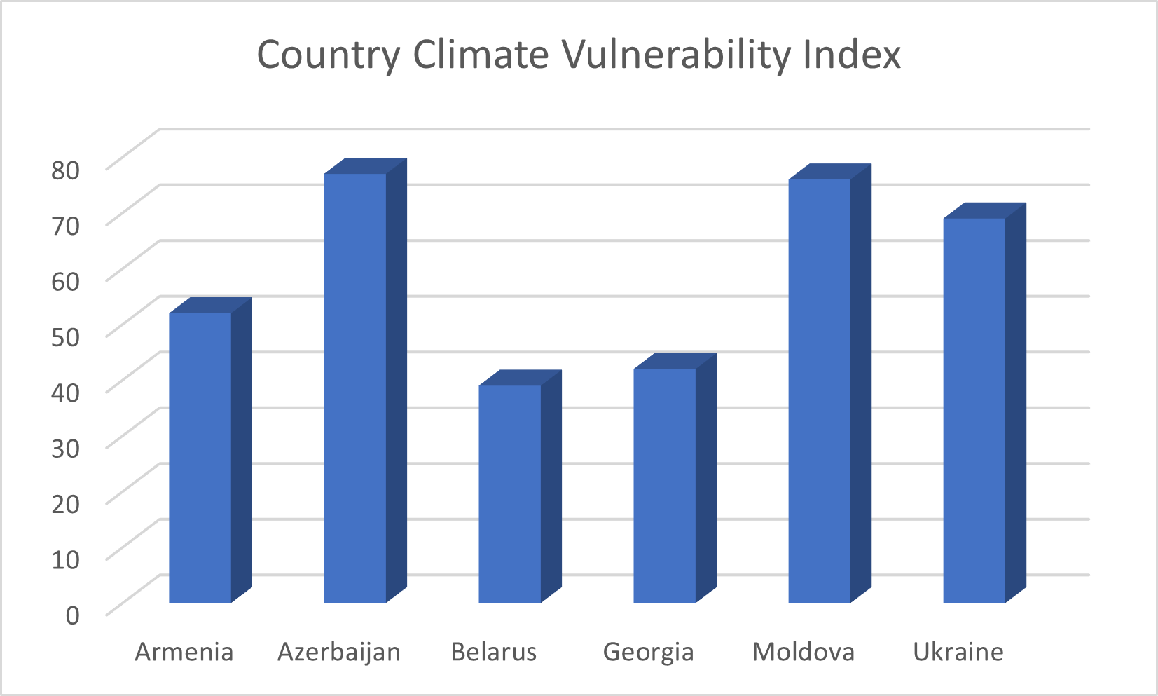
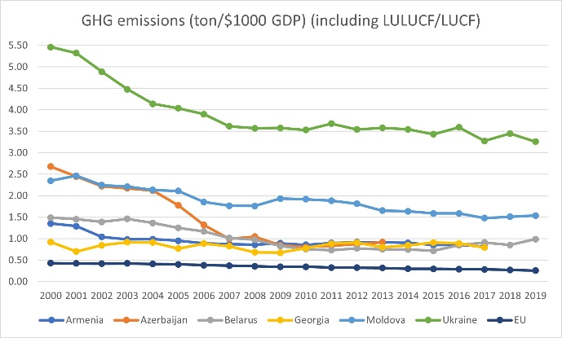 |  | ND-GAIN Country Index, composed of vulnerability and readiness score, ranks the vulnerability of countries to the impacts of climate change; a higher number means a higher vulnerability. (As developed by the University of Notre Dame).
Partner Countries:
Armenia, Azerbaijan, Belarus, Georgia, Republic of Moldova, Ukraine
Duration:
2019-2023

Budget:
EUR 8.8 million
(EU contribution: EUR 8 million)
Implementing Partner:
United Nations Development Programme (UNDP)

Overall direction:
European Commission
This country profile was produced with the financial assistance of the European Union. The views expressed herein can in no way be taken to reflect the official opinion of the European Union, its members, or the Governments of the Eastern Partnership Countries. This document and any content included herein are without prejudice to the status of, or sovereignty over, any territory, to the delimitation of international frontiers and boundaries, and to the name of any territory, city, or area.
The views expressed in this publication are those of the author(s) and do not necessarily represent the views of the United Nations Development Programme, the United Nations generally, or United Nations Member States.
eu4climate.eu
facebook.com/UNDPEurasia
twitter.com/UNDPEurasia
youtube.com/UNDPEurasia
Success story about the draft law on F-gases
The need to regulate fluorinated greenhouse gas (F gases) emissions is included in the EU-Moldova Association Agreement. Moldova is expected to adopt national F-gas legislation, in line with Regulation (EC) No 842/2006 of the European Parliament and of the Council of 17 May 2006. EU4Climate provided assistance to the Ministry of Environment of Moldova with developing and approving the law on fluorinated greenhouse gases.
The law is designed to mitigate climate change and protect the environment by reducing emissions of fluorinated greenhouse gases and taking measures to prevent emissions of f-gases throughout their life cycle by gradually reducing the import and consumption of hydrofluorocarbons (HFCs).
The proposed legislative intervention will create the legal framework for the reduction of fluorinated greenhouse gas emissions in order to mitigate climate change and protect the environment as a whole. The proposed goal will be achieved by regulating measures for isolation, leakage prevention, use, recovery and destruction of F gases. At the same time, the law prohibits the introduction on the market of some equipment and products containing F gases with high global warming potential and gradual reduction of imported quantities of hydrofluorocarbons.
The draft law is expected to accelerate the greening of refrigeration and air conditioning systems operating on HFCs. In addition to environmental protection, alternative refrigerants such as CO2, isobutane, propane, ammonia, etc., will also offer great energy-saving potential as available technologies allow a smarter and more sustainable use of systems using artificial cold.
The effective monitoring of F gas emissions is essential for tracking the progress made in order to meet the emission reduction objectives. The Law of Moldova on fluorinated greenhouse gases was approved by the Parliament in the first reading on 01.12.2022.

http://www.clima.md/doc.php?l=ro&idc=82&id=4317
https://gain.nd.edu/our-work/country-index/rankings/
Participation of Belarus in the EU4Climate was suspended as of 24.02.2022 until further notice.

